**SCHOOL DRESS CODE**

**Dress Code**

The following dress code has been established for St. Therese School. It is primarily the responsibility of the

parent/guardian to enforce this code by seeing that children leave for school, neat, clean and properly attired.

**Girls**

**Shirts**

* Collared, plain white, or red/black with school logo
* Long or short sleeve
* No ruffles, lace, embroidery, or any other logo
* Undershirts should be red, black, white, & navy
* Must be tucked in

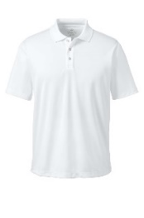  

**Sweaters**

* Cardigan or pull over (No hood)
* Logo free
* White or navy
* Must have a uniform shirt under

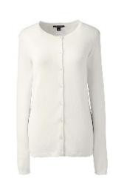 [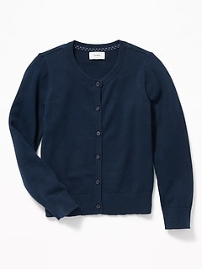](https://oldnavy.gap.com/browse/product.do?pid=447303032&cid=36516&pcid=36516&vid=1&grid=pds_21_199_1&cpos=21&cexp=1483&cid=CategoryIDs%3D36516&cvar=11128&ctype=Listing&cpid=res20052007450410444499184)

**Sweatshirts/Fleece coat**

* Grey, red or black crew neck St. Therese logo sweatshirts
* Navy blue crewneck sweatshirts without logos
* No hoodies worn in the building
* St. Therese red or black fleece jacket may be worn anytime
* Must have a uniform shirt under

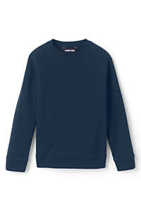 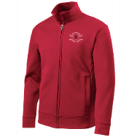 

**Jumper/Skirt/Skort**

* Jumper K- 3rd grade only
* Skirt/Skort K-8
* Navy, Khaki or School Plaid
  + You can order the school plaid from Schoolbelles
* Must be no shorter than 3 inches from the knee

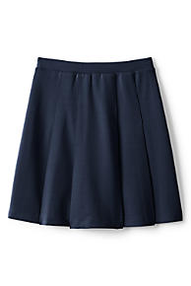 [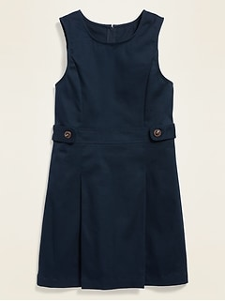](https://oldnavy.gap.com/browse/product.do?pid=578746022&cid=36516&pcid=36516&vid=1&grid=pds_188_195_1&cpos=192&cexp=1483&cid=CategoryIDs%3D36516&ctype=Listing&cpid=res2005200718368186903357) [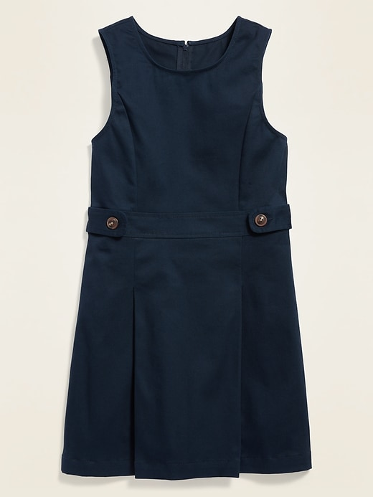](https://www1.assets-gap.com/webcontent/0018/748/617/cn18748617.jpg) 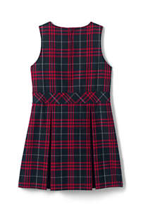 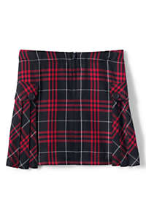

**Leggings/Tights**

* Worn under skirt or jumper ONLY
* Navy, black, or white
* No labels, logos, words, or graphics

**Socks**

* Must wear socks with shoes
* Solid color socks only

**Hair**

* Clean and combed out of eyes
* No extreme hairstyles (at principal’s discretion)
* No extreme coloring- natural hair coloring only

**Make-Up**

* No facial make-up

**Jewelry/Tattoos/Piercings**

* No more than 2 earrings in each ear
* No large dangling earrings
* No nose, eyebrow, or lip piercings
* Religious or medical necklace or bracelet
* Watch (no smart watches)
* No tattoos (temporary and/or permanent)

**\*\*\*If your student is not in compliance with dress code they will be given a school uniform to wear for the day.\*\*\***

**Boys**

**Shirts**

* Collared plain white, or red/black with school logo
* Long or short sleeve
* Undershirts should be red, black, white, navy
* Must be tucked in

  

**Sweaters**

* Cardigan, vest, or pull over (no hood)
* White or navy
* No logos
* Must have a uniform shirt under

[](https://oldnavy.gap.com/browse/product.do?pid=447303032&cid=36516&pcid=36516&vid=1&grid=pds_21_199_1&cpos=21&cexp=1483&cid=CategoryIDs%3D36516&cvar=11128&ctype=Listing&cpid=res20052007450410444499184) 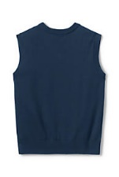

**Sweatshirts/Fleece coat**

* Grey, red or black crew neck St. Therese logo sweatshirts
* Navy blue crew sweatshirts without logos
* No hoodies worn in the building
* St. Therese red or black fleece jacket may be worn anytime

 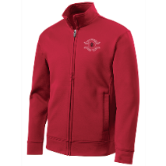

**Socks**

* Must wear socks with shoes
* Solid color socks only

**Hair**

* Clean and combed out of eyes
* No extreme hairstyles-fad cuts, man-buns, symbols cut into the hair (discretion of the principal)
* No extreme coloring- natural colors only
* Clean shaved face

**Make-Up**

* No facial make-up

**Jewelry/Tattoos/Piercings**

* No earrings
* No nose, eyebrow, or lip piercings
* Religious or medical necklace or bracelet
* Watch (no smart watches)
* No tattoos (temporary and/or permanent)

**\*\*\*If your student is not in compliance with dress code they will be given a school uniform to wear for the day.\*\*\***

**ALL STUDENTS**

**Footwear:**

* Gym shoe style (Recommended)
* NO: cowboy boots, sandals, backless shoes, clogs, flip-flops, water shoes, crocs, high heels and Ugg Boots or similar boots
* Snow boots for recess are permitted for recess only
* Socks or tights must be worn at all times
* Shoes are at the principal discretion
* Shoes with laces that are meant to be tied must be tied

**Pants/Shorts**

* Navy or Khaki full-length pants only
* No frayed, cut offs or holes
* No skinny style, flair legged, bell bottoms, or overalls
* No cargo, or back pockets (see diagram)
* Navy or Khaki shorts (worn in the 1st and 4th quarter only) no outside pockets, no shorter than 3 inches above the knee
* Belt must be worn if pants/shorts have belt loops
  + Solid colored belts must be worn

NOT ALLOWED 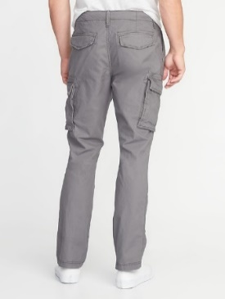 NOT ALLOWED 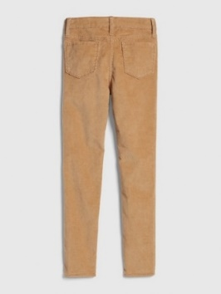

CORRECT PANTS 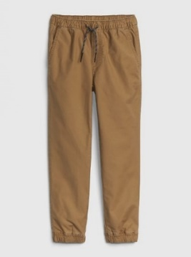 CORRECT PANTS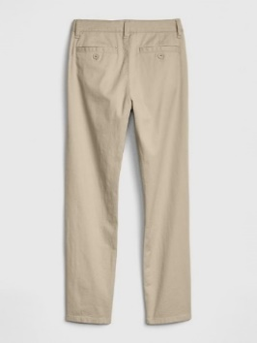

Correct shorts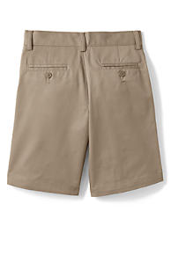

**Dress up days:**

Students will be expected to be in dress-up clothes or their regular school uniforms

Clothing worn on these days should be clothing that would be worn on a special occasion.

* Dress pants (No jeans, athletic pants, or leggings)
* Dress shirt, polo shirt, or sweater (no spaghetti straps, low cut shirts, t-shirts, mid-drift shirts, or shirts with writing of any kind)
* Girls- dresses or skirts (no shorter than 3 inches above the knee) (no spaghetti straps, low cut, t-shirt dresses) (No jean dresses or skirts) (leggings under skirt or dress only)
* No shorts

**Dress down days:**

Clothing on these days is to be more casual. It must be neat, not torn, and cannot have holes.

* Jeans, joggers, cargo pants (no holes)
* khaki pants
* athletic pants (no see-thru)
* NO LEGGINGS
* modest shirts (no tank tops, sleeveless shirts, spaghetti straps, mid drift tops permitted)
* T-shirts (inappropriate writing is not permitted)
* sweatshirts (inappropriate writing is not permitted)
* spirit wear items
* Shorts are permitted during hot weather dress time, but they must be no shorter than 3 inches above the knee. (No biker shorts) (Not torn, frayed, or holes)

**\*\*\*If your student is not in compliance with dress code they will be given a school uniform to wear for the day.\*\*\***

**Physical Education Dress Code:**

* Students are required to wear approved gym clothes for Physical Education classes (4th grade-8th grade) K-3 will wear regular everyday uniform
  + These include:
    - Red PE shirt with small St. Therese logo, purchased from the school office (not the school collared shirt)
    - Black gym shorts may be worn during the 1st and 4th Quarters (no more than 3 inches above the knee)
    - No marking soles, non skid, gym shoes
    - Black sweatpants must be worn during 2nd and 3rd quarter. (**Yoga pants or leggings are NOT permitted)**

**Spirit Days**

* 1 spirit day a month
  + Short or long sleeve spirit tee shirts
  + Must wear uniform bottoms

**Masks**

* Plain (any color), solid-colored masks, or masks with our school color uniform plaid.
* Masks may not contain words, letters, messages, or distracting images. Any images must be school appropriate.
* The administration reserves the right to determine school appropriateness.

**THE PRINCIPAL/PASTOR HAS THE RIGHT TO AMEND THE UNIFORM POLICY AT ANY TIME.**

**PARENTS WILL BE GIVEN PROMPT NOTIFICATION.**